ALLEN ORTHOTICS AND PROSTHETICS

2502 West Ohio Avenue 1921 East 37th Street, Suite A
Midland, Texas Odessa, Texas
432-683-3788 432-332-9821

Aspen Cervical Collar and Pad Set
Function:

Your cervical orthosis is design to restrict motion in your neck during the healing process following injury or surgery.

The following instructions will help you understand how to apply, adjust and care for your collar. Please review this information with whoever will be helping you. Be sure to follow all instructions you have been given by your doctor.

Use:

1. Place the front of the collar so your chin comes to the front edge of the chin piece.
2. Place the back panel behind your neck. Be sure the Support Strap is at the top.
3. Connect the Velcro on both sides and tighten.
4. To tighten the Support Strap, squeeze the back panel with one hand. Loosen the strap from one side and pull until tight. Connect the strap to the Velcro patch. Tighten the Support Strap until it is comfortable.

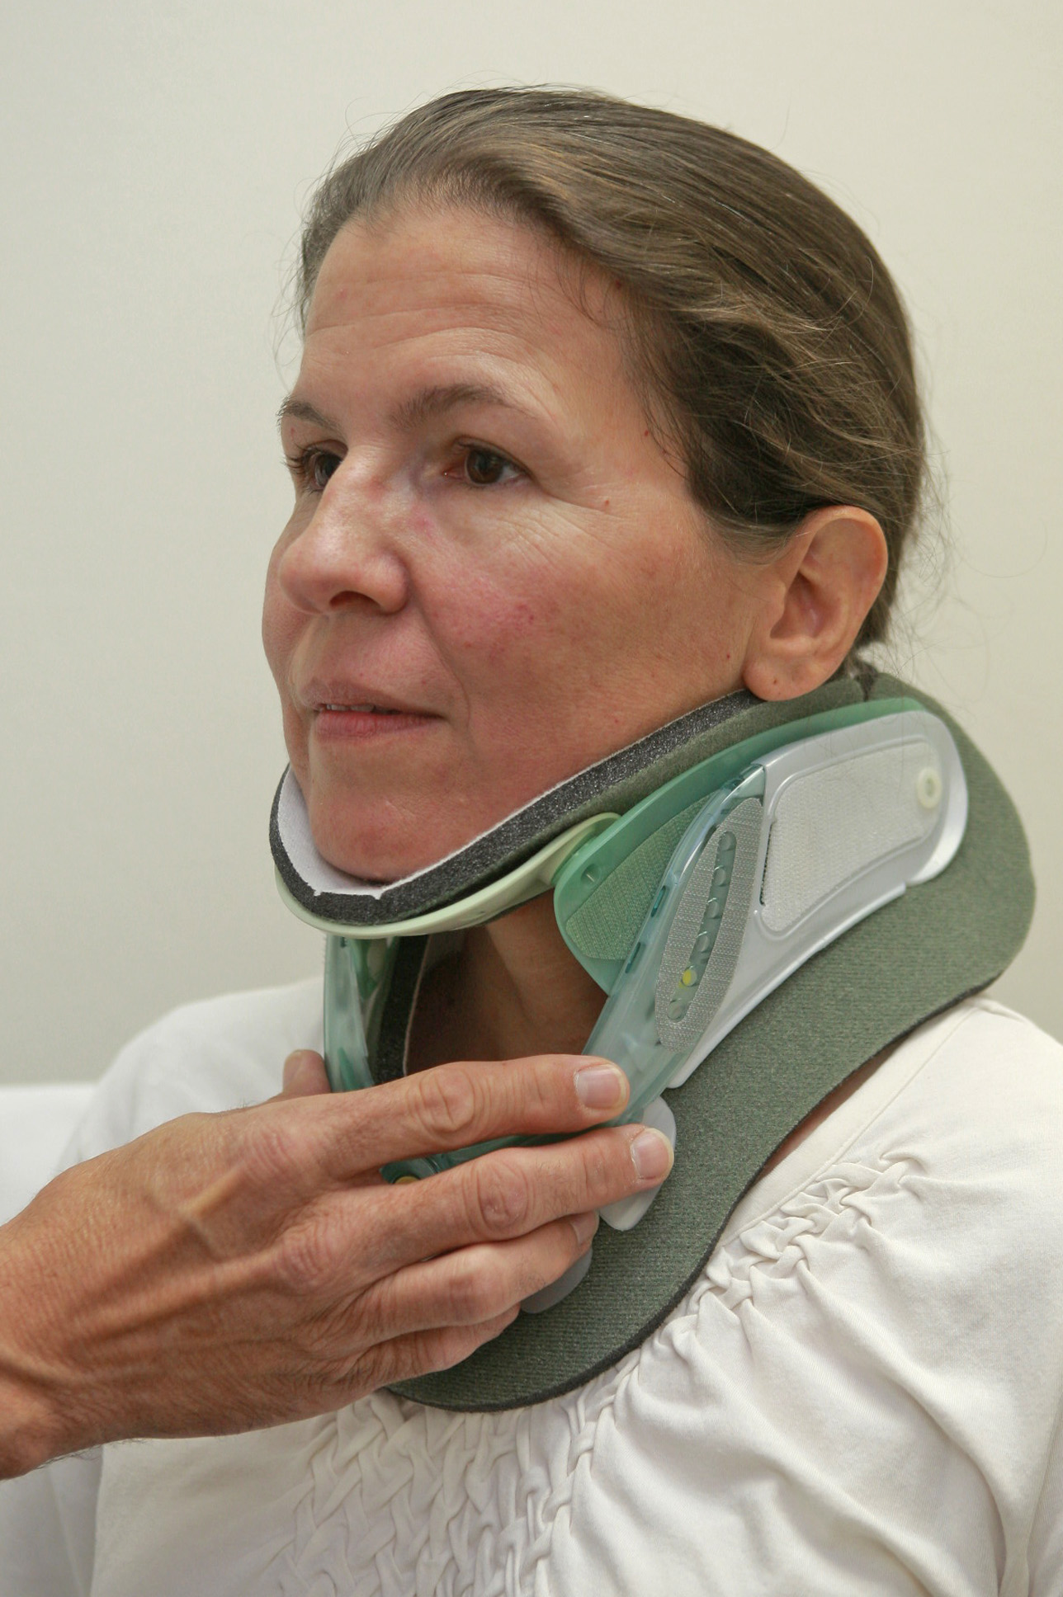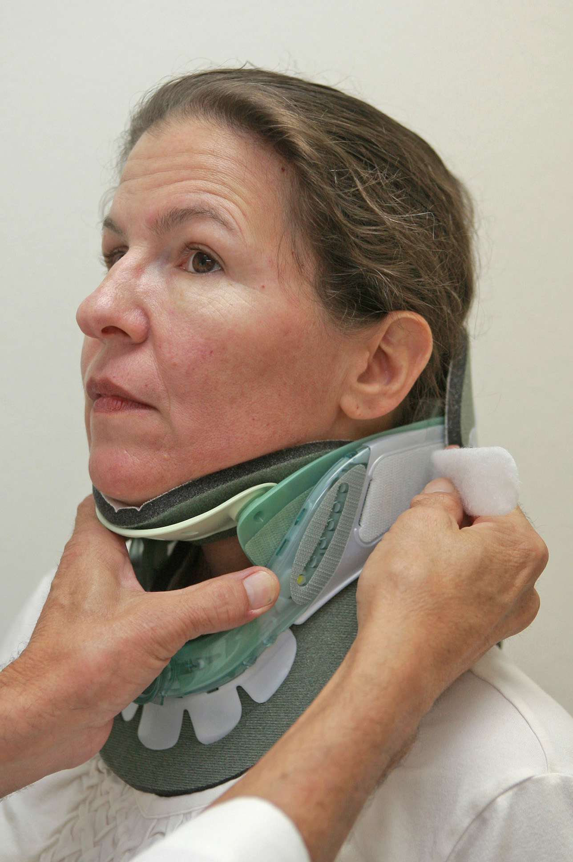

5. Before taking off your collar, gather the supplies you will need: soap, wash cloth, towel, and pads.
6. Note where the Velcro straps end on the front of the collar. This will help when you apply and tighten the collar following skin care.
7. If possible, stand or sit in front of a sink with a mirror. Release the Velcro on one side. Remove the collar and set it aside.
8. Keep your head and neck straight and still. Use a wash cloth to clean your face and neck.
9. Rinse away soap and gently dry your skin.
10. Remove moist and/or dirty pads. If needed, clean and towel dry the plastic and Velcro. Attach the clean pads.

Care/Maintenance

Proper Skin Care
Pressure, moisture, heat, and dirt can all lead to skin redness and sores so be sure to inspect the skin for pressure areas, redness, irritation, skin breakdown, pain, or edema. To avoid problems, keep your skin clean, dry and cool. At least once a day, remove the collar and wash your face and neck. At this time, moist or dirty pads should be changed. Check with your doctor about how to keep your head and neck still while the collar is off. If you notice any skin redness or sores, call your doctor or the person who fitted the collar.

Pad cleaning
Hand wash the pads with mild soap and water. Triple rinse (until all soap and residue is removed) and gently squeeze out excess water. Allow to air dry (6-8 hours). Do not use bleach or place pads in a washer or dryer.

Pad Replacement
Adjust the pads so the gray side grips the Velcro dots. The pads must cover all edges of the plastic. If not, move the pad to keep the plastic from touching the skin.

To change the back pad, push the Velcro straps through the slits in the pad and then through the slits in the outer edge of the plastic.

Proper fit
When the collar has been properly applied, your chin comes to the front edge of the chin piece.

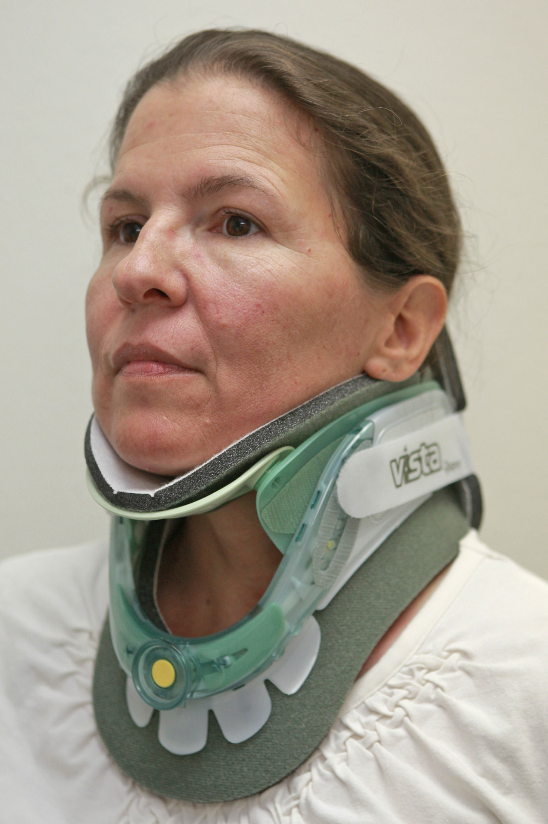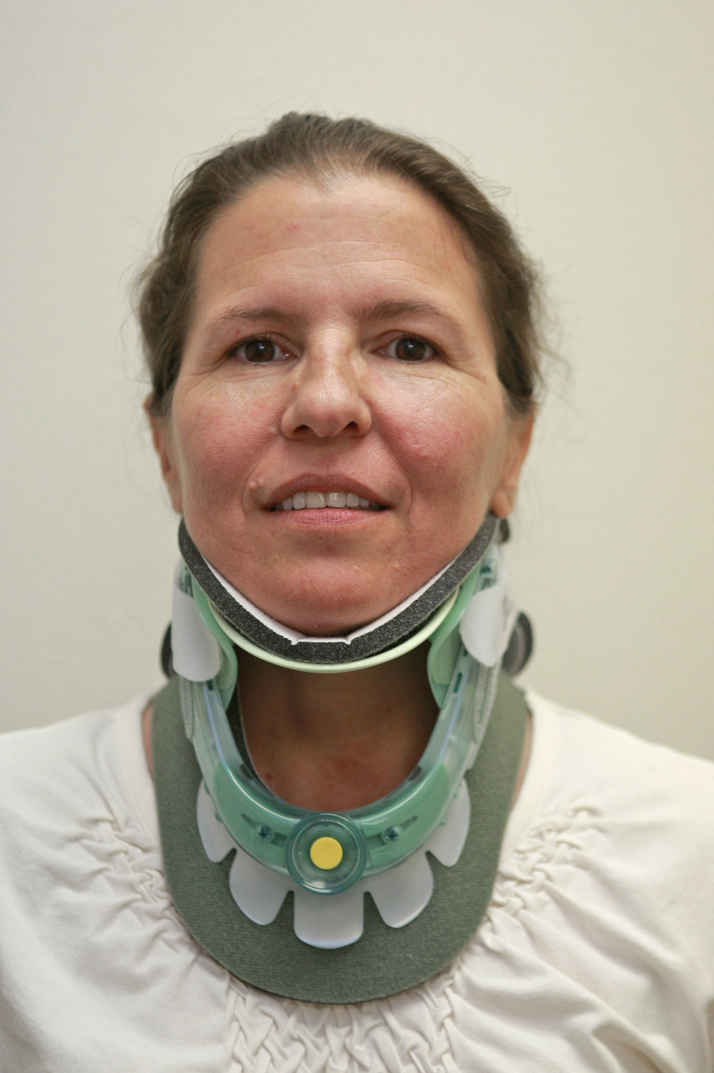

Precautions:
Keeping your head and neck as still as possible is important to the healing process. Leave your collar on and properly tightened at all times. Remove it only to wash your face and neck unless you have been given other orders from your doctor. Remove your collar only with the help of another person.

Report failures, malfunctions or changes in your physical condition to us as soon as possible.

